Locality Management

In geography, statistics and archaeology, a settlement, locality or populated place is a community in which people live. A settlement can range in size from a small number of dwellings grouped together to the largest of cities with surrounding urbanized areas. Settlements may include hamlets, villages, towns and cities. A settlement may have known historical properties such as the date or era in which it was first settled, or first settled by a particular people.
In terms of geographical hierarchy city comprises of suburbs which in turn comprise various localities.
NOTE :
Consider any project that is active in either or both Makaan/PropTiger then it must not comprise of inactive localities.
Thus it is evident that active localities cannot be grouped/occur under inactive suburb(s).
The status of localities created in the CMS portal may be either one of Active or Inactive or Active in Makaan.
It also supports a search engine for searching localities by providing input parameters City and Status (Active in Makaan/Inactive).

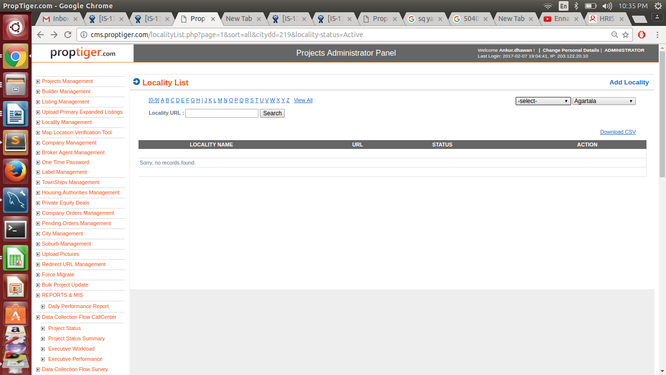

Add Locality

This is to create new localities with a few mandatory fields like Locality Name, Meta Title, Meta Keywords, Meta Description, Parent Suburb, Status.

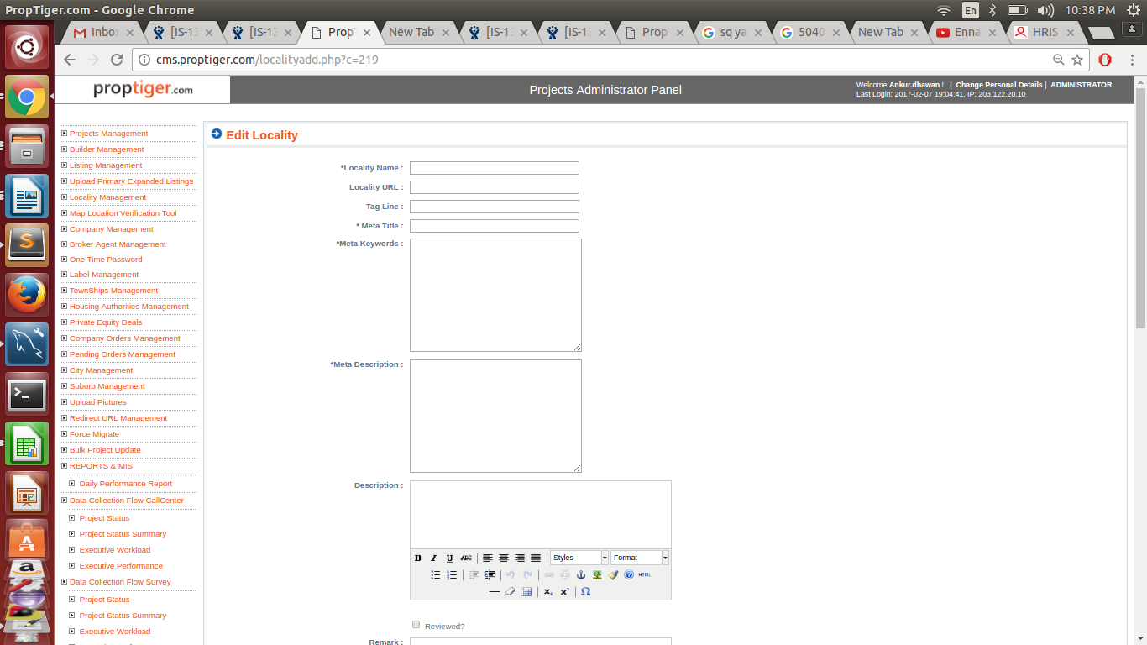

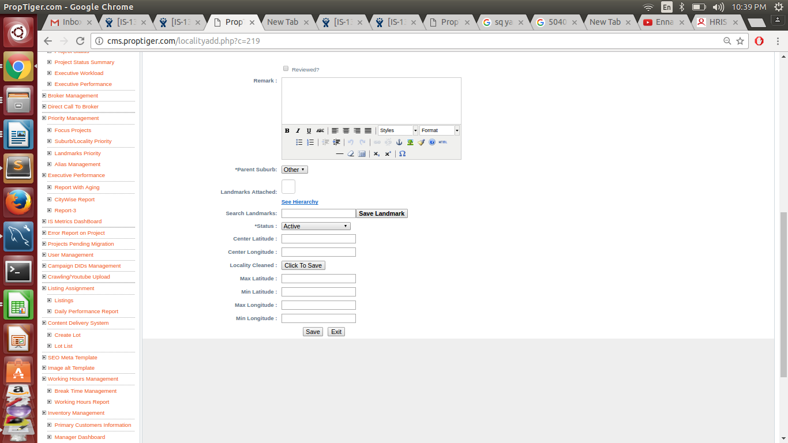

In which there are two sections, add and search

Search Locality:-

1.City search. (drop down) City ( label )
2.Status (drop down) City
3. url City

Add Locality:

All field are fiile in locality table.

1. * Locality Name locality (label)
2. locality url locality (url)
3. Tag line.
4. * Meta Title seo_data
5. * Meta Keywords seo_data
6. * Meta description seo_deta
7. Description locality ( description)
8.Reviewed
9. Remark.
10. * Parent suburb locality (suburb_id)
11. Landmark Attached
12. Search landmark.
13.* Status. locality
14. Center Latitude. locality
15. Center Longitude. locality
16.Locality Cleaned. locality
17.Max latitude. locality
18.Mix latitude. locality
19.Max longitude. locality
20.Min longitude. locality

All * mark are mandatory filled.

Query:

Query for checking mandatory filed is null.

Select lo.label,sd.meta_title,sd.meta_keywords,sd.meta_description ,lo.suburb_id,lo.statusfrom locality lo
join seo_data sd on lo.locality_id=sd.table_id where sd.table_name='locality'
or( (lo.label is null or lo.label =' ') or (sd.meta_title is null or sd.meta_title=' ')
or (sd.meta_keywords is null or sd.meta_keywords=' ') or (sd.meta_description is null or sd.meta description=' ') or (lo.suburb_id is null or lo.suburb_id=' ') or (lo.status is null or lo.status=' ')) and lo.status='active';

